**Korea Multimedia Society Copyright Transfer Agreement**

|  |  |
| --- | --- |
| Title of the Manuscript: | Generative Adversarial Networks based on Parallel Structured Generators for Training Stability |
|  |  |
| Author(s): | *Bumchan Park, **Inshil Doh, *Dana Yang |
|  |  |
| Affiliation(s): | *Dept. of Computer Software, Graduate School, Korea Bible University,  **Dept. of Cyber Security, School of AI, Ewha Womans University |

All copyright of the above manuscript, including rights for publishing in any media, are transferred to the Korea Multimedia Society.

The authors retain the following rights :

1. All proprietary rights other than copyright.

2. Re-use of all or part of the above manuscript in their work.

3. Reproduction of the manuscript above for author’s personal use or for company/institution use provided that

(a) the permission of the Korea Multimedia Society is obtained prior to reproduction

(b) the source and Korea Multimedia Society copyright notice are indicated, and

(c) the copies *per se* are not offered for sale

4. The consent of the author (or one of the authors) be sought as a condition in granting republication permission to others.

I hereby agree above Copyright Transfer Agreement.

date / month / year : 23 / Jan / 2024

Authorized signature (handwritten) 1: 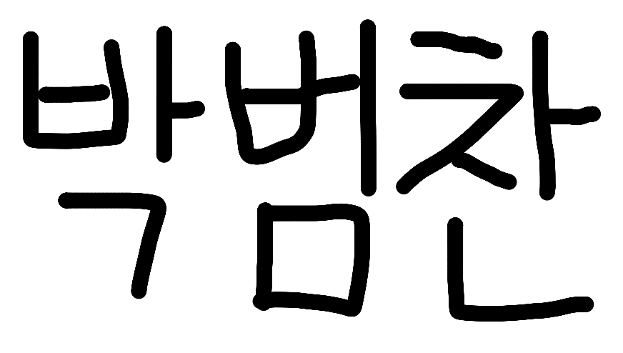

Authorized signature (handwritten) 2: 

